Name:________________________________________
Line
Line is an element of art. In fact, line is one of the most important elements of art. Line is defined as a continuous mark made by a series or string of points. It can be used to show the outline of a shape, to create texture, pattern and value and to suggest moods.

Practice using different kinds of lines here as we discuss the properties of lines.
Types of Lines
Actual Lines | Implied Lines | Straight | Curved | Zigzag

Direction of Lines
Vertical | Horizontal | Diagonal | Parallel | Perpendicular

Variations of Lines
Short | Long | Thin | Thick | Smooth | Rough

Moods of Lines
Angry | Happy | Confused | Sleepy

Repeated Lines | Patterned Lines

Value
Value is the element or art that expresses the variation in hue (a.k.a. color) ranging from lightest to darkest. This includes tones (pure color mixed with white) and shades (pure color mixed with black)

Practice showing different kinds of value here as we discuss the properties of lines.
Grayscale

Six Techniques for creating Value

Blending |  | Crosshatching |  | Stippling

Hatching |  | Modeling |  | Gradation
A contour line is an outline, or a line that defines the interior and exterior edges of an object. There are several types including continuous contour, implied contour, and blind contour. Contour drawings DO NOT include small details or shading.
Contour Lines

Continuous Contour Implied/ Modified Contour
A Continuous Contour Line drawing has An Implied Contour Line Drawing has a
clean, connected line. clean, broken line.

*Notice how the lines are not wobbly or sketchy, but smooth and clean

Practice:
In boxes below attempt to do a continuous contour line drawing and a modified contour line drawing.
Blind Contour
Blind contour line drawings are slow, careful contour drawings of observations done without looking at the paper. These drawings help an artist focus on capturing the outlines only- the curves of the lines and the connections between the lines.

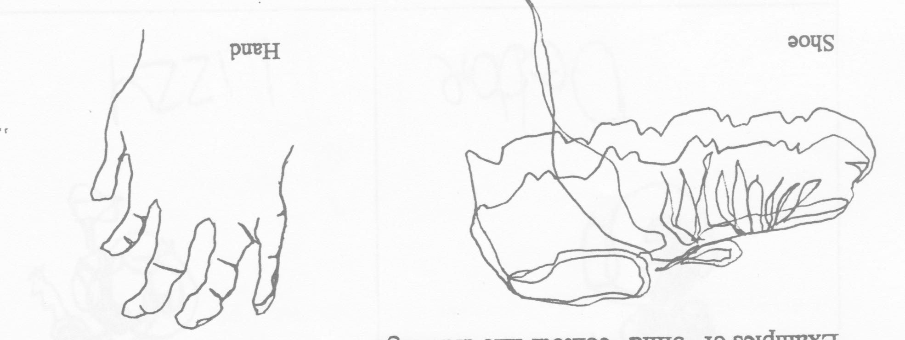

Practice:
In boxes below attempt to do blind contour studies of your classmates, remember try to look ONLY at the person you are drawing and not at the paper at all. This is difficult to do! Don’t worry about what the drawing looks like- just focus on following the lines with your eye and drawing them with your hand.

Gesture Drawing
Gesture Drawing is a way of expressing the action in a drawing in short quickly created studies. These are typically done of people, though sometimes also animals. Drawings are done rapidly and continuously in a ceaseless line, from top to bottom, around and around without taking your pencil off the page. The focus is no longer on the outer edges of a form but on the position and movement of the figure without regard for minute details. Work with the whole figure not sections. Gesture drawings attempt to capture all sorts of positions- sitting, standing, kneeling, stooping, lying down, leaning on something- from all viewpoints- front, back, and side.
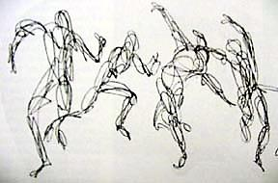
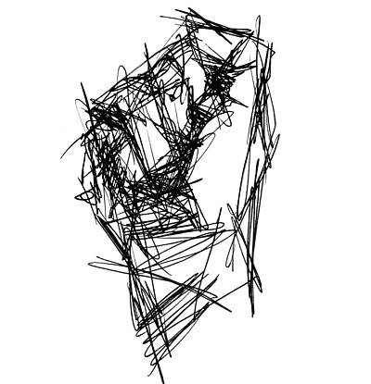

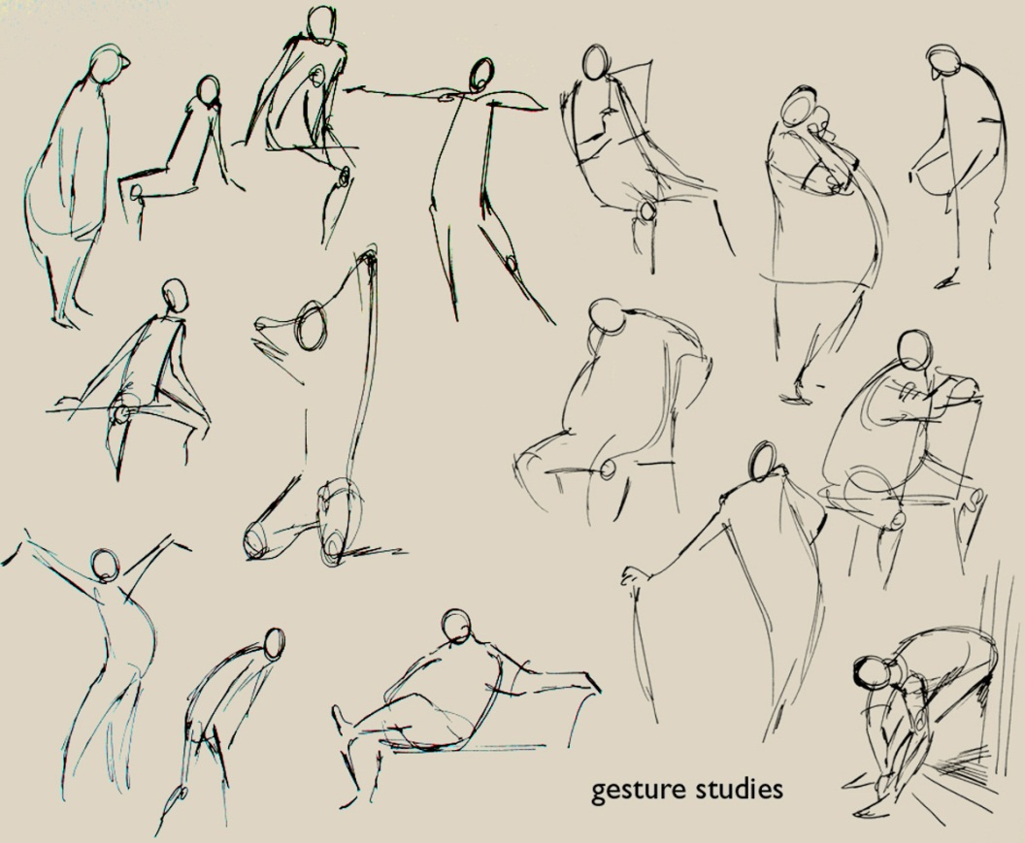
Practice:
Use the boxes below to create a series of gesture drawings based on student poses in class.

Simplified Structure Drawings
Sometimes it can be daunting to jump right into an observational drawing. Trying to balance getting the details correct and keeping the proportion of the object is something that artists spend years perfecting. One technique that artist use to help is starting with an under drawing of the simplified structure. This is created by breaking up a complex from in to simple geometric shapes which when combined make up the basic architecture of the object.
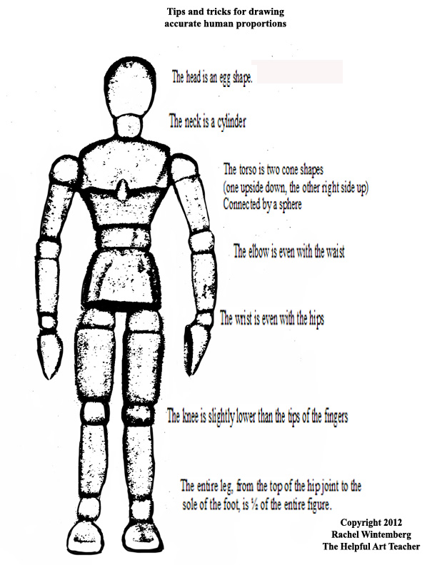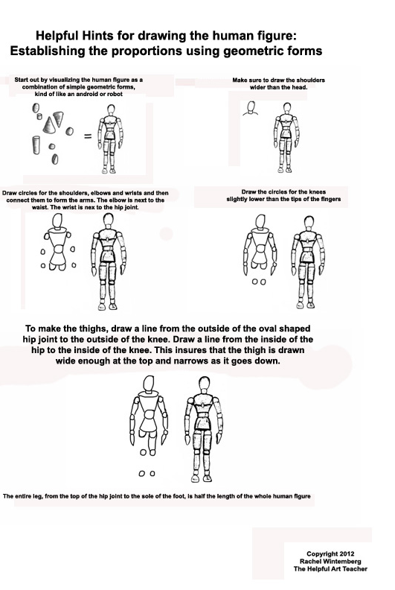

To keep these drawings in the correct proportions, artists use relative measurements. Relative measurements are when you draw one small section of an object and then your measure in the air in front of you how many times that distance fits into other areas of the object. Then by translating that number to your drawing you stay proportional.
Example: There are 7 head lengths in the height of the body.
Practice:
Use the Guides below to help you build a drawing of your hand from simple shapes.
